Central Idea- WIN

Central Idea: http://bit.ly/2acThfE Central Idea: http://bit.ly/2acThfE

Central Idea: http://bit.ly/2acThfE Central Idea: http://bit.ly/2acThfE

Central Idea: http://bit.ly/2acThfE Central Idea: http://bit.ly/2acThfE

Central Idea Notes

- Central Idea is the ________________________ an author is trying to make.

- It is _________________ that the passage is _______________.

- What supports the central idea?

  - W- __________ or _____________ the story is about.
  - I- _______________ information about the _________ or _________.
  - N- In a small _______________ of words.

Central Idea Notes

- Central Idea is the ________________________ an author is trying to make.
- It is _________________ that the passage is _______________.
- What supports the central idea?

  - W- __________ or _____________ the story is about.
  - I- _______________ information about the _________ or _________.
  - N- In a small _______________ of words.

Central Idea Classwork

- Crop Circles
W-

I-

N-

- Amelia Earnhardt
W-

I-

N-
- Stonehenge
W-

I-

N-
- History of Writing
W-

I-

N-
- Bermuda Triangle
W-

I-

N-
- Good Grades
W-

I-

N-

- Garfield
W-

I-

N-

- Mama’s Boyz (Pie)
W-

I-

N-
- Mama’s Boyz (Broken Tablet)
W-

I-

N-

Classwork
http://www.englishworksheetsland.com/grade6/readinginfo/2/1bermuda.pdf

http://www.englishworksheetsland.com/grade6/readinginfo/2/2writing.pdf

http://www.englishworksheetsland.com/grade6/readinginfo/2/3stonehenge.pdf

http://www.englishworksheetsland.com/grade6/readinginfo/2/4crops.pdf

http://www.englishworksheetsland.com/grade6/readinginfo/2/5earhardt.pdf

Good Grades
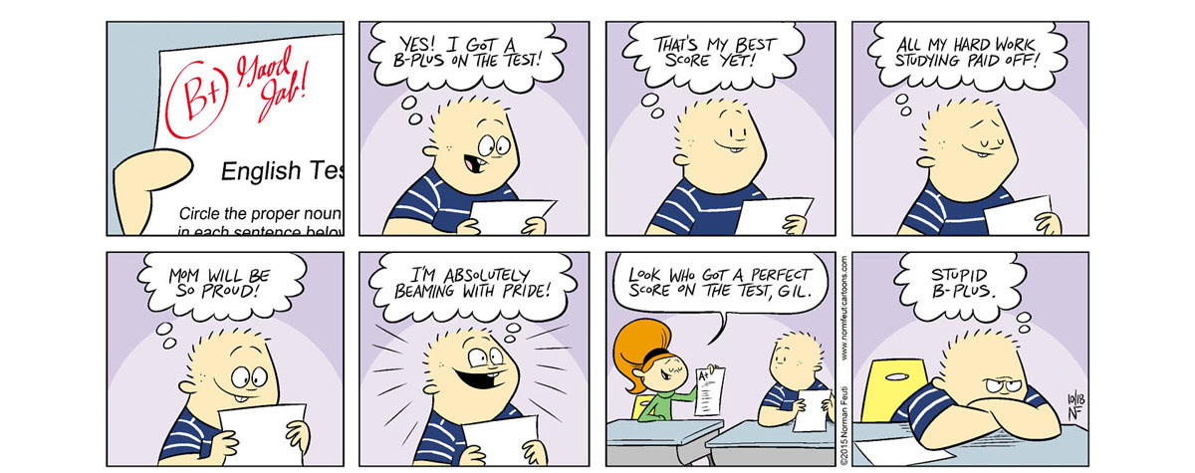

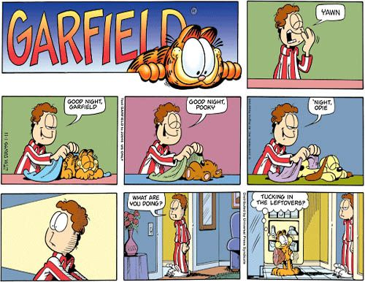

Mama’s Boyz Pie
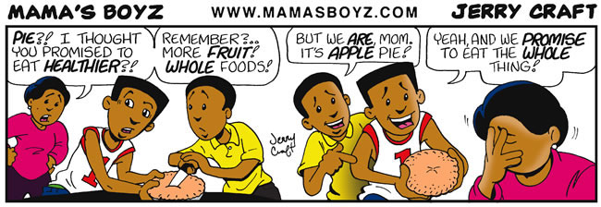

Mama’s Boyz Broken Tablet
